Supreet Jain

Why Bundle Transactions Fail and How to Avoid Them

📄 Why Bundle Transactions Fail and How to Avoid Them

Introduction
In certain scenarios, bundle transactions fail due to product rules or customer account restrictions. To minimize failures and improve customer experience, we have identified the primary causes and implemented a new API flow to handle them efficiently.

Reasons for Bundle Failure
Bundle transactions may fail due to two primary reasons:
1. Dynamic Nature of Bundles
- Some products require the mobile number to be passed in order to retrieve the list of applicable bundles.
- Only bundles applicable to that specific number can be purchased.
- If this validation skipped then transaction may fail
2. Outstanding Loan Amount
Customers may owe a loan amount to the operator. If a customer has an outstanding loan, they cannot purchase a bundle package until the loan is cleared. Operators expect customers to:
- The loan amount is paid first, or
- The loan amount is paid along with the bundle purchase.
- This validation is enforced by the operator to ensure financial dues are cleared before provisioning new services.

Solution: Enhanced API Flow
To address these issues and prevent bundle failures, we’ve developed a new API flow that:
- Returns the list of applicable plans for a given mobile number.
- Provides the loan amount (if any) associated with the number. We returned in:
  - Wallet currency
  - Delivered (Destination Currency)
  - Face Value currency
Important Note – This loan amount is not included Face Value or delivered amount value.
This information is also available via the Number Lookup API.

Recommended Flow
Step-by-Step Integration:
- Call the Bundle Catalog API:
- GET /api/v2/catalog/bundles/{ProductId}/{MobileNumber}
  - This returns:
    - Applicable plans for the mobile number.
    - Loan amount details (if any).
- Review Loan Amount:
  - Loan amount is provided in:
    - Wallet currency
    - Delivered currency
    - Face value currency
  - Important: The loan amount is not included in the plan’s face value. Use correct loan amount values. If you are sending transaction in your wallet currency then use loan amount in wallet. Otherwise use loan amount in face value currency.
- Top-Up API Consideration:
  - When initiating a top-up, ensure the loan amount is added to the plan’s face value.
  - Pass the combined amount in the amount field of the Top-Up API request.

Example Flow
Scenario:
- Customer wants to purchase a bundle worth $5.
- Customer has a loan amount of $2.
Process:
- Call api/v2/catalog/bundles/{ProductId}/{MobileNumber}.
- API returns:
  - Bundle: $5
  - Loan: $2
- Add loan amount to plan face value:
  - Total = $5 + $2 = $7
- Pass $7 in the Topup API 'amount' field.
- Transaction succeeds.

Flow Charts
  - Flow Chart:
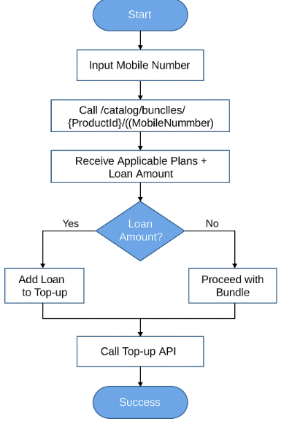

  - Sequence Diagram
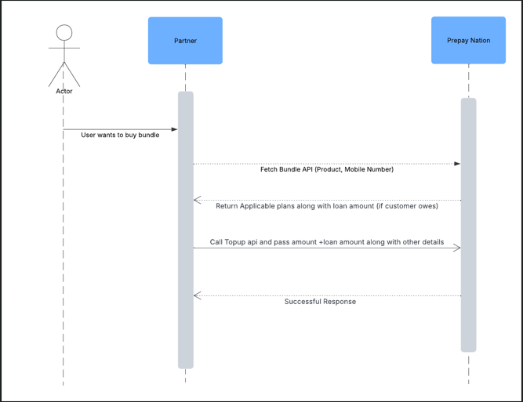

✅ Best Practices
- Always perform a Fetch Bundle or number lookup before initiating a bundle purchase.
- Validate both plan eligibility and loan status.
- Ensure the total amount (plan + loan) is passed correctly to avoid rejection.

